Hardware 3
Y12 - Cambridge International 9618 | IA Term 1B review + 3.1 | Student booklet
Name: _______________________________ | Date: _____________

This booklet has everything you need for the lesson in one place. Work through it in order:
- Learn sections show the key slides. Read them carefully - they explain the ideas and show worked examples.
- Task sections are where you practise. Each task uses what the slides just before it taught you.
- Tasks get harder as you go and use real Cambridge 9618 Paper 1 questions. Task 6 is an extension.
Learn IA Term 1B review
Your teacher will go through these slides. Then close the booklet on them and do Task 1 without looking back.
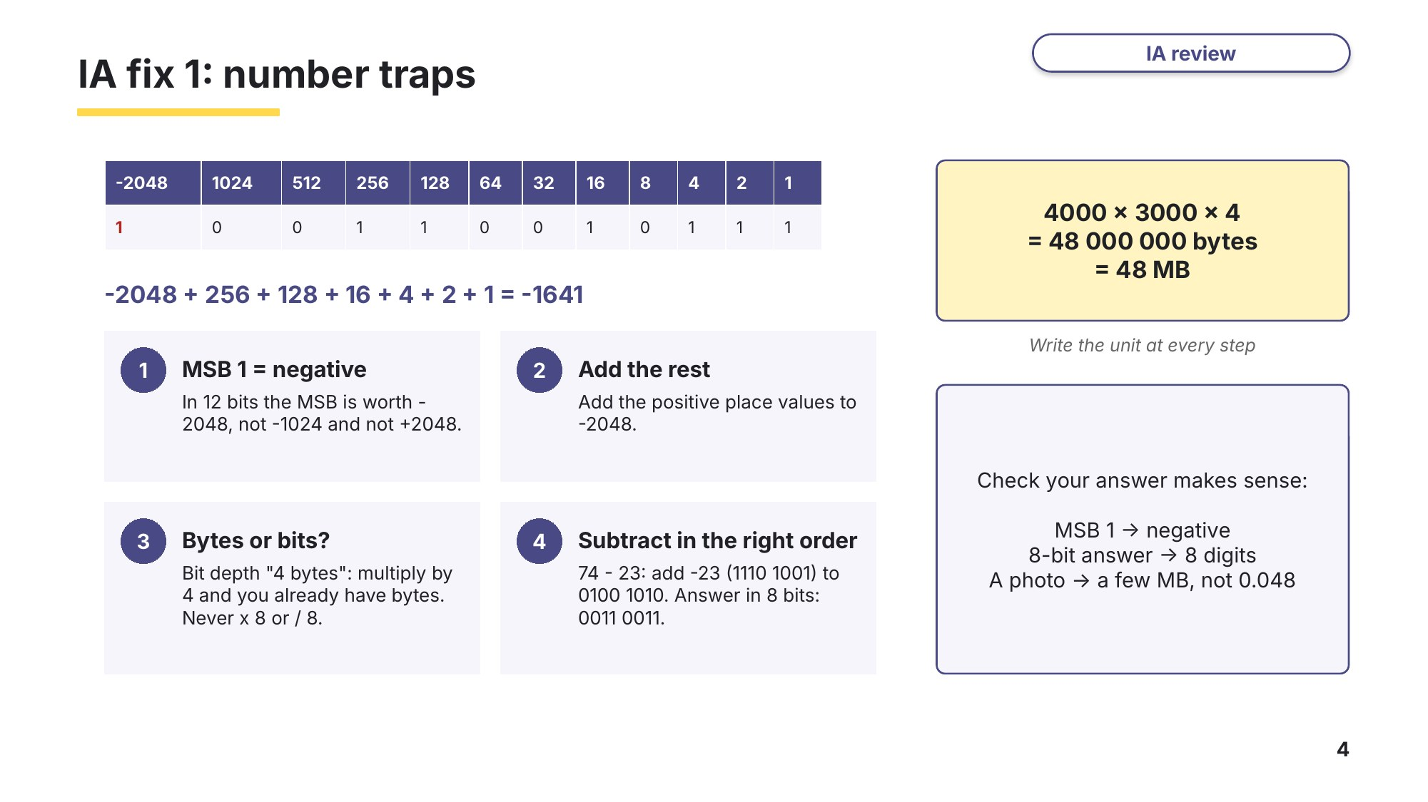
Slide 4 - IA fix 1: number traps
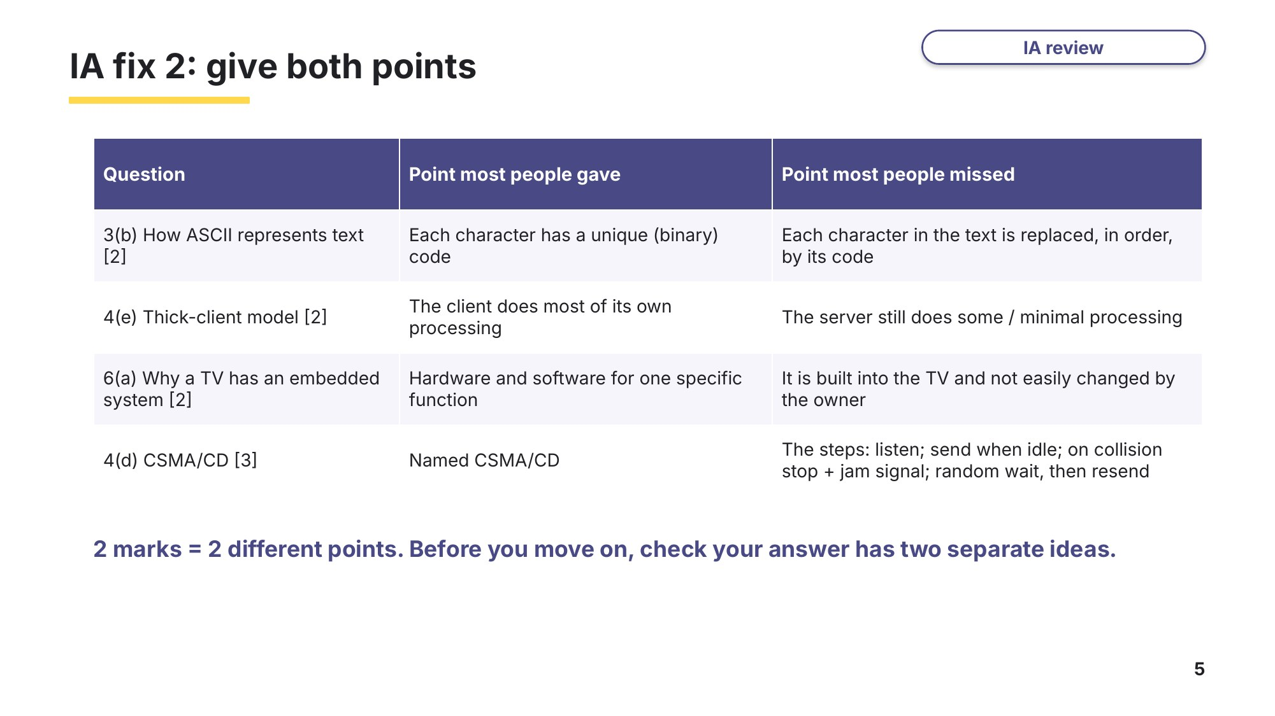
Slide 5 - IA fix 2: give both points
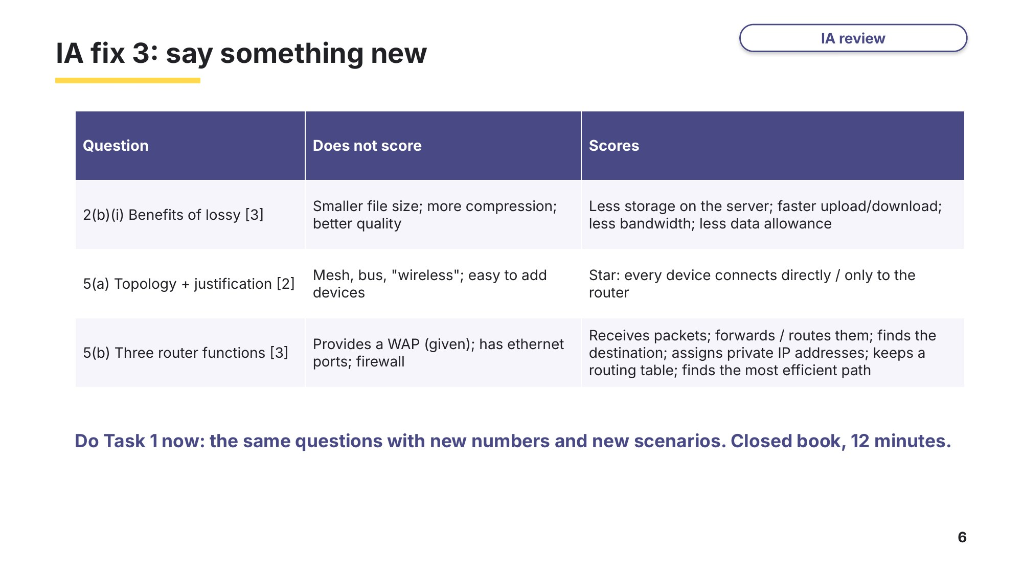
Slide 6 - IA fix 3: say something new

Task 1 IA fix-up [16 marks]
Closed book. 12 minutes. These are the IA Term 1B questions that lost the most marks, with new numbers and new scenarios. Use the habits from slides 4-6: check the sign and the units, and give two different points for 2 marks.
(a) Convert the 12-bit two's complement binary number into denary. [1]
1 | 1 | 0 | 0 | 0 | 1 | 0 | 1 | 1 | 0 | 1 | 0
Answer ..........................................
(b) Subtract the denary number 38 from the two's complement binary number 0110 0001. Perform this calculation using binary subtraction. Show your working. [2]
Working
Answer ..........................................
(c) A photograph is 2000 pixels wide and 1500 pixels high. The bit depth is 3 bytes. Calculate an estimate for the file size of the photograph in megabytes. Show your working. [2]
Working
Answer ............................... megabytes
(d) The photograph is uploaded to a social media website. Give three benefits of compressing it using lossy compression instead of lossless compression. [3]
"A smaller file" does not score: give the consequences of the smaller file.
1 ......................................................................................................................................................
2 ......................................................................................................................................................
3 ......................................................................................................................................................
(e) The name of the photograph is stored using the ASCII character set. Explain how text is represented by the ASCII character set. [2]

(f) A school network uses a thick-client model. Describe what is meant by a thick-client model. [2]

(g) Mai's laptop, phone and tablet each connect wirelessly to the router in her flat. Identify the topology of Mai's home network. Justify your choice. [2]
Topology ..........................................
Justification ..................................................................................................................................
(h) Identify two functions of the router in Mai's network. Do not give "provides a wireless access point". [2]
1 ......................................................................................................................................................
2 ......................................................................................................................................................

Learn Input and output devices
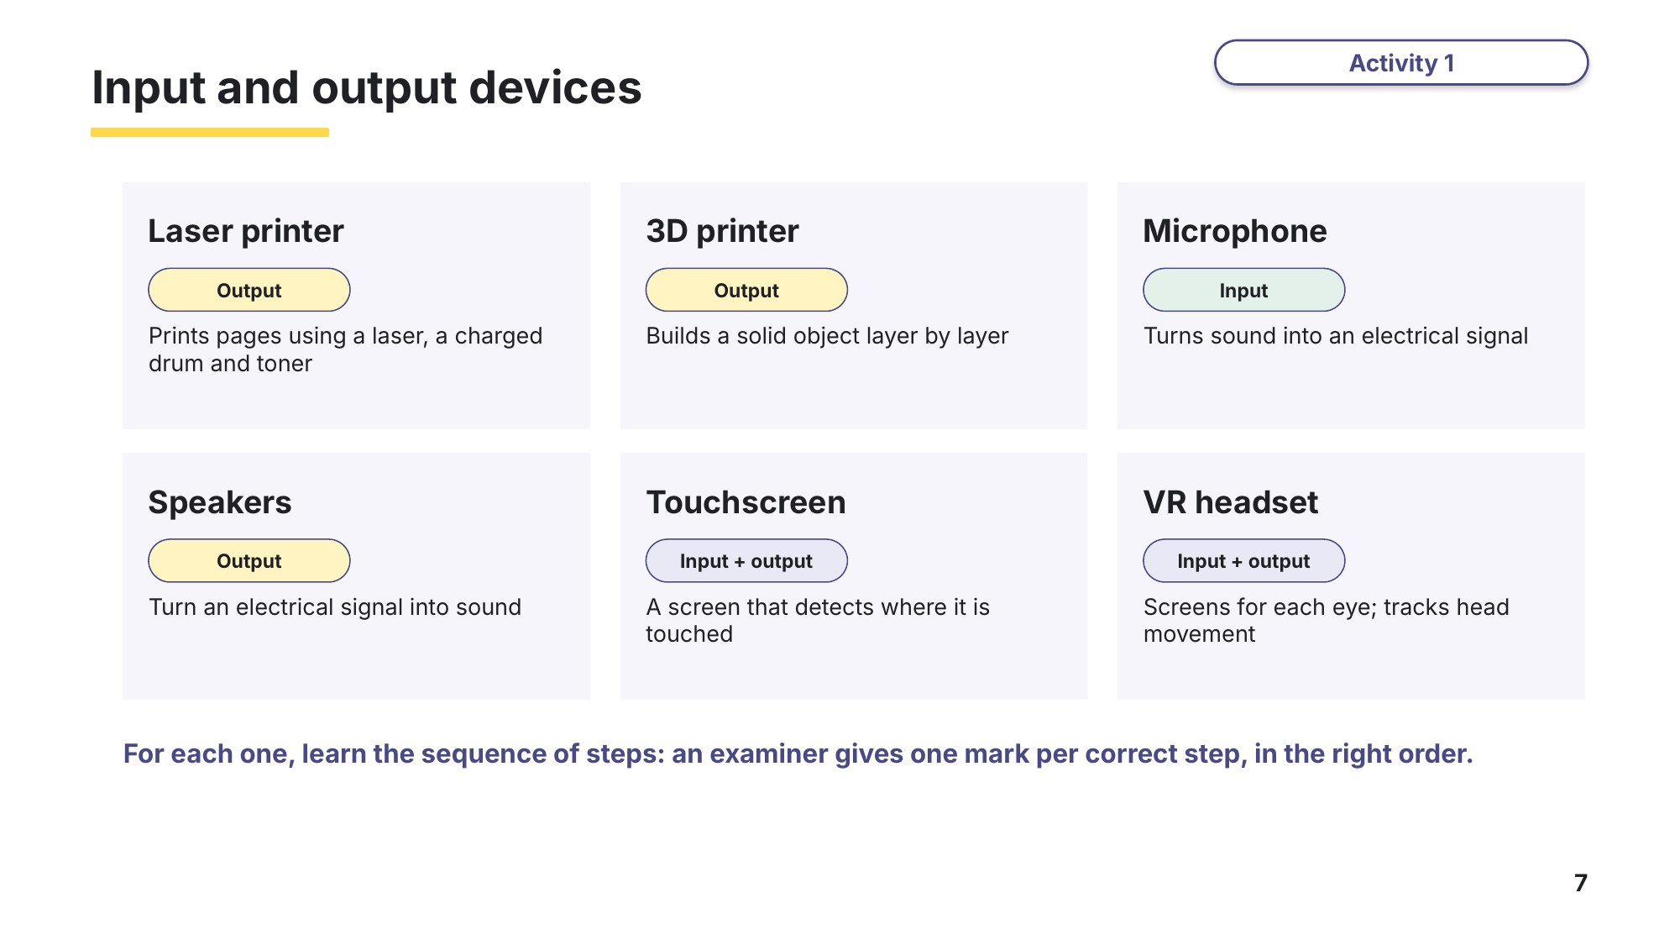
Slide 7 - Input and output devices
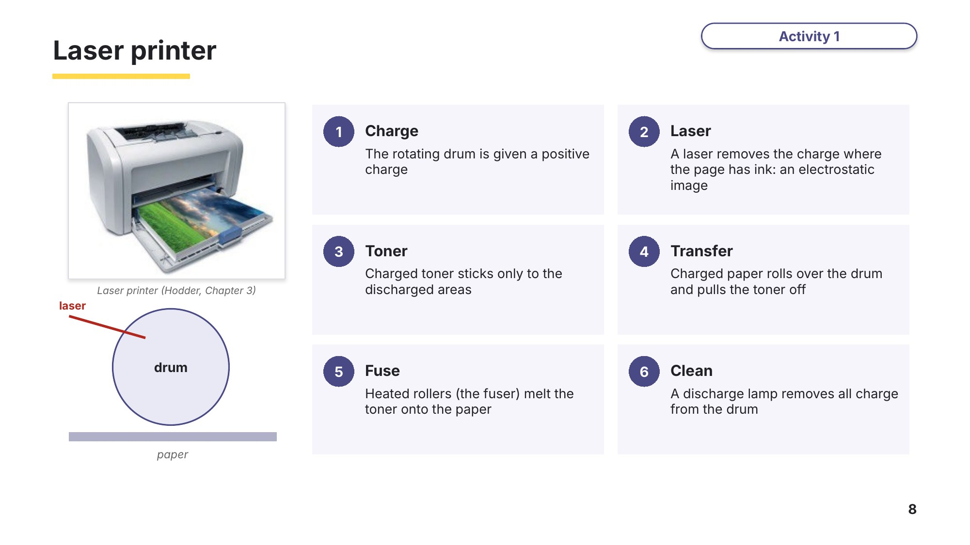
Slide 8 - Laser printer
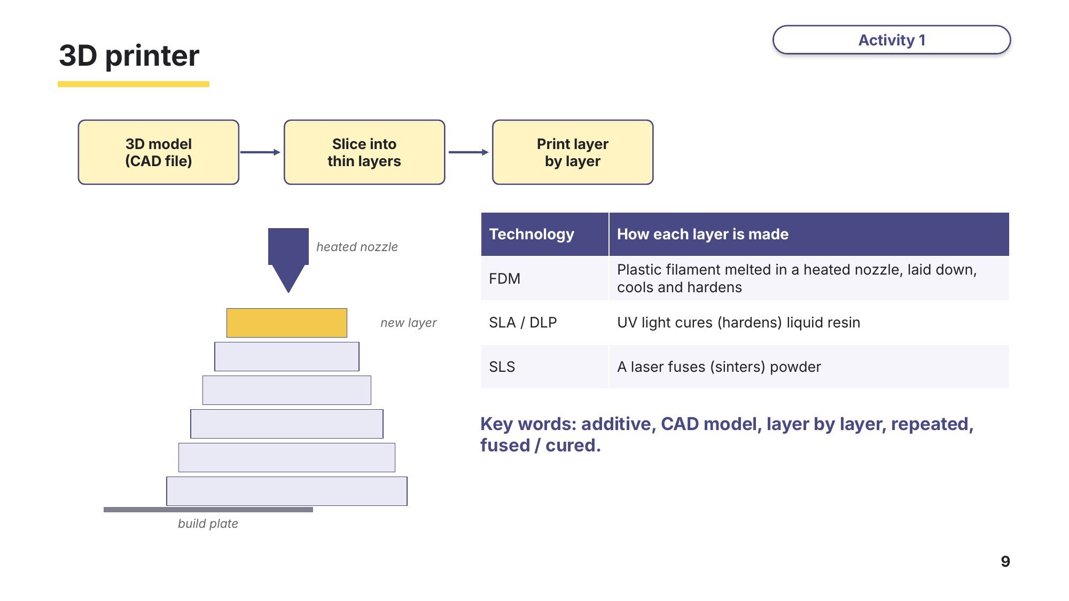
Slide 9 - 3D printer
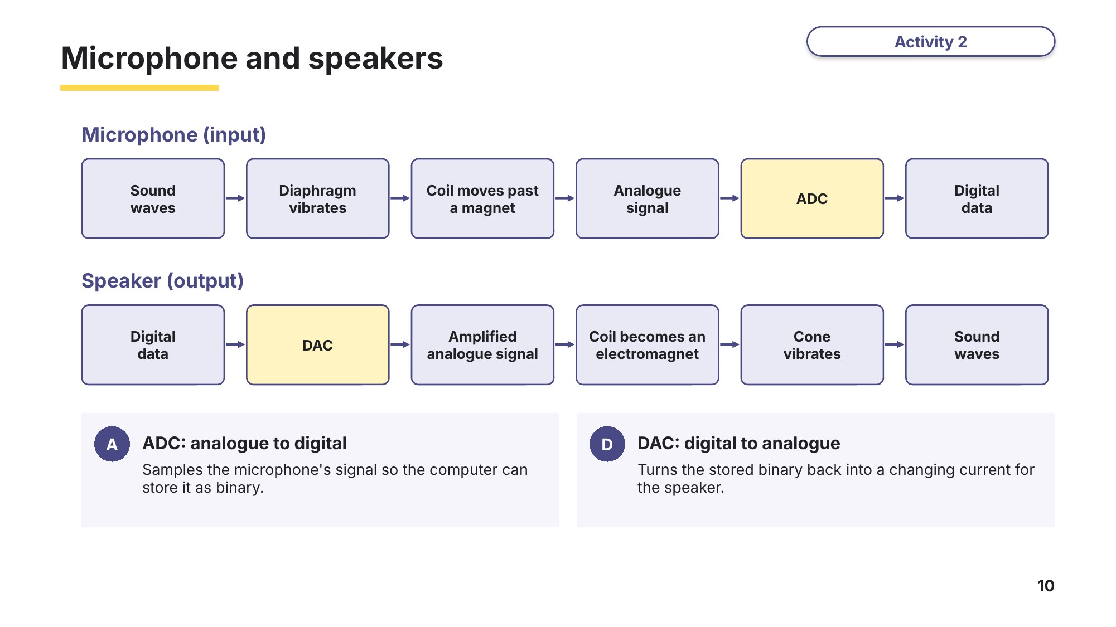
Slide 10 - Microphone and speakers
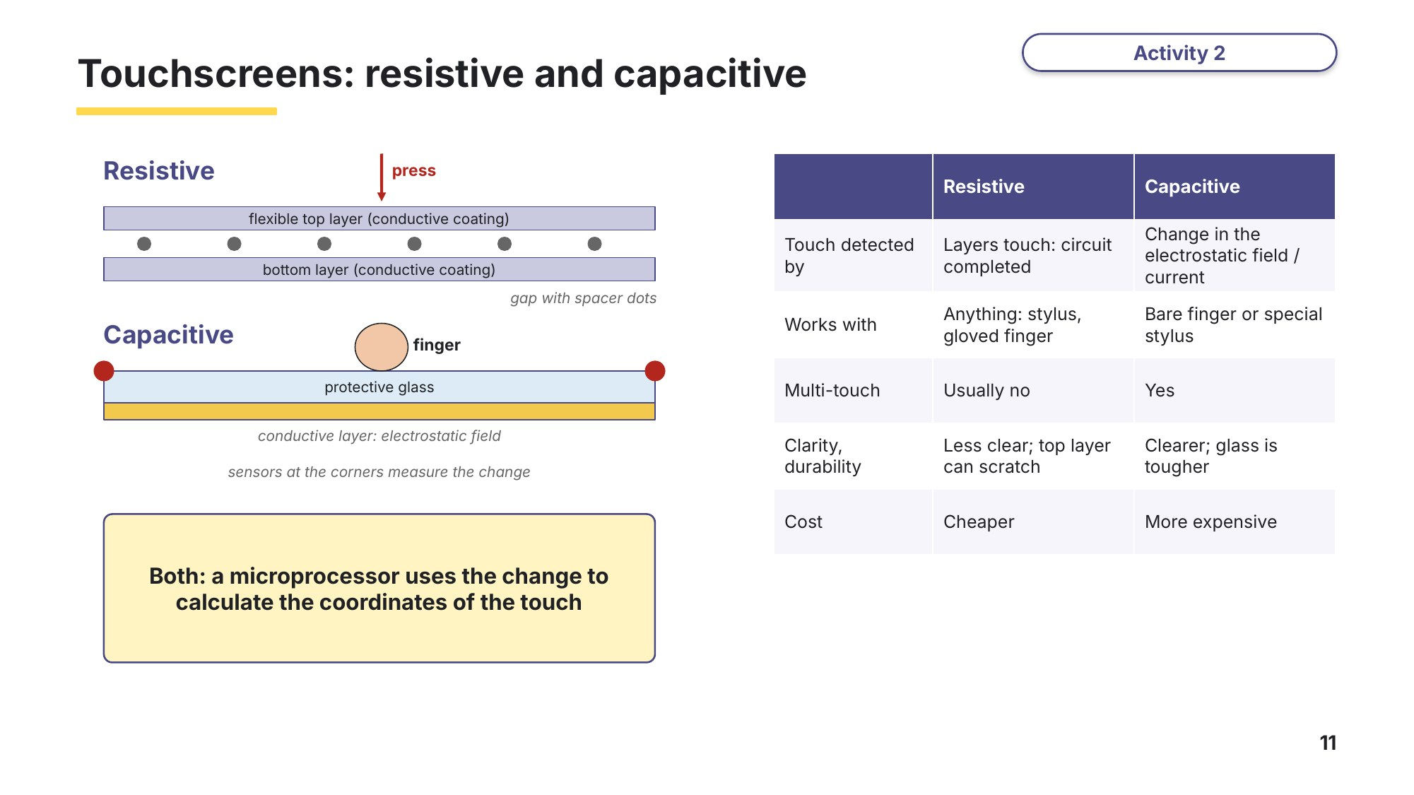
Slide 11 - Touchscreens: resistive and capacitive
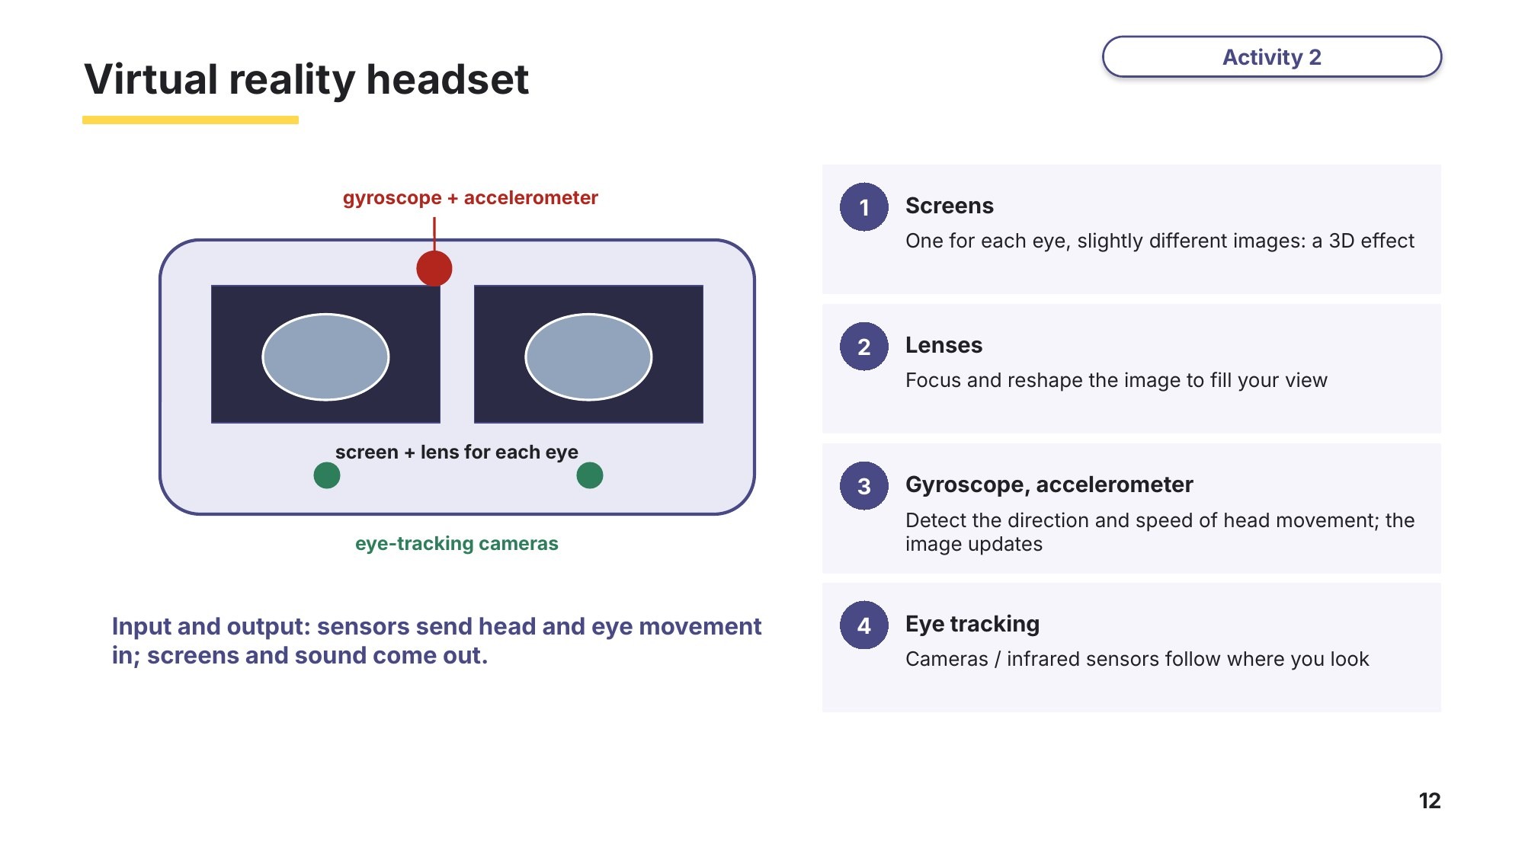
Slide 12 - Virtual reality headset

Task 2 Laser printers and other devices [12 marks]
(a) The statements describe how a laser printer prints a page, but they are in the wrong order. Write the letters in the correct order. [6]
Letter | Statement
A | Heated rollers (the fuser) melt the toner so that it is fixed to the paper
B | The rotating drum is given a positive charge
C | A discharge lamp removes all the charge from the drum, ready for the next page
D | A laser beam removes the charge from the drum where the page has text or images
E | Charged toner sticks only to the discharged areas of the drum
F | A charged sheet of paper rolls over the drum and the toner transfers to the paper
Correct order: 1 ........ 2 ........ 3 ........ 4 ........ 5 ........ 6 ........
(b) Name the device or component that each statement describes. [6]
Statement | Device or component
Has a screen for each eye and a gyroscope that detects head movement
Builds a solid object by adding thin layers of melted plastic
A coil acting as an electromagnet makes a cone vibrate to produce sound
Two conductive layers are pushed together to complete a circuit
Sound waves make a diaphragm vibrate, which moves a coil past a magnet
Changes stored binary data into an analogue signal before it reaches a speaker

Task 3 Touchscreens, sensors, monitoring and control [18 marks]
(a) Complete the description of touchscreens using words from the list. Not all the words are used. [5]
Based on 9618/13 May/June 2023 Q3(a).
actuator capacitive change circuit coordinates laser pressure resistive
A .............................. touchscreen has two flexible layers separated by a small gap. When the screen is pressed, the two layers touch and complete a .............................. at that point.
A .............................. touchscreen has a conductive layer that holds an electrostatic field. A finger touching the screen causes a .............................. in the electrostatic field at the point of contact.
In both types, a microprocessor uses this to calculate the .............................. of the point that was touched.
(b) Tick one box in each row to show which type of touchscreen each statement describes. [4]
Statement | Resistive | Capacitive
Works when the user is wearing ordinary gloves
Can detect two or more touches at the same time (multi-touch)
Detects a change in the electrostatic field
Usually cheaper to manufacture

Task 4 Exam questions: input and output devices [20 marks]
A school design and technology department uses a 3D printer to make plastic parts for its robots.
(a) Describe the principal operations of a 3D printer. [3]
Based on 9618/11 Oct/Nov 2023 Q7(a).

(b) The 3D printer has a temperature sensor. Describe the purpose of the temperature sensor in the 3D printer. [2]
Based on 9618/11 Oct/Nov 2023 Q7(b).

(c) Students record a podcast using a microphone. Describe the principal operation of a microphone. [3]
Based on 9618/12 Oct/Nov 2021 Q3(a).

(d) Complete the description of the principal operation of a virtual reality (VR) headset. [4]
Based on 9618/12 May/June 2024 Q2(a).
The headset has a separate .............................. for each eye, viewed through lenses, so the user sees a 3D image.
A .............................. and an accelerometer detect the .............................. and speed of the user's head movement, and the image is updated to match.
Digital .............................. inside the headset track the movement of the user's eyes.
(e) A teacher prints a set of worksheets on a laser printer from a laptop. Describe how the laser printer makes use of a buffer. [4]
Based on 9618/13 Oct/Nov 2023 Q7(c).

(f) Describe how a laser printer produces a printed page. [4]

Learn Check your Task 4 answers
Only look at this slide once you have finished Task 4. Mark (a), (c) and (e) against the official marking points.
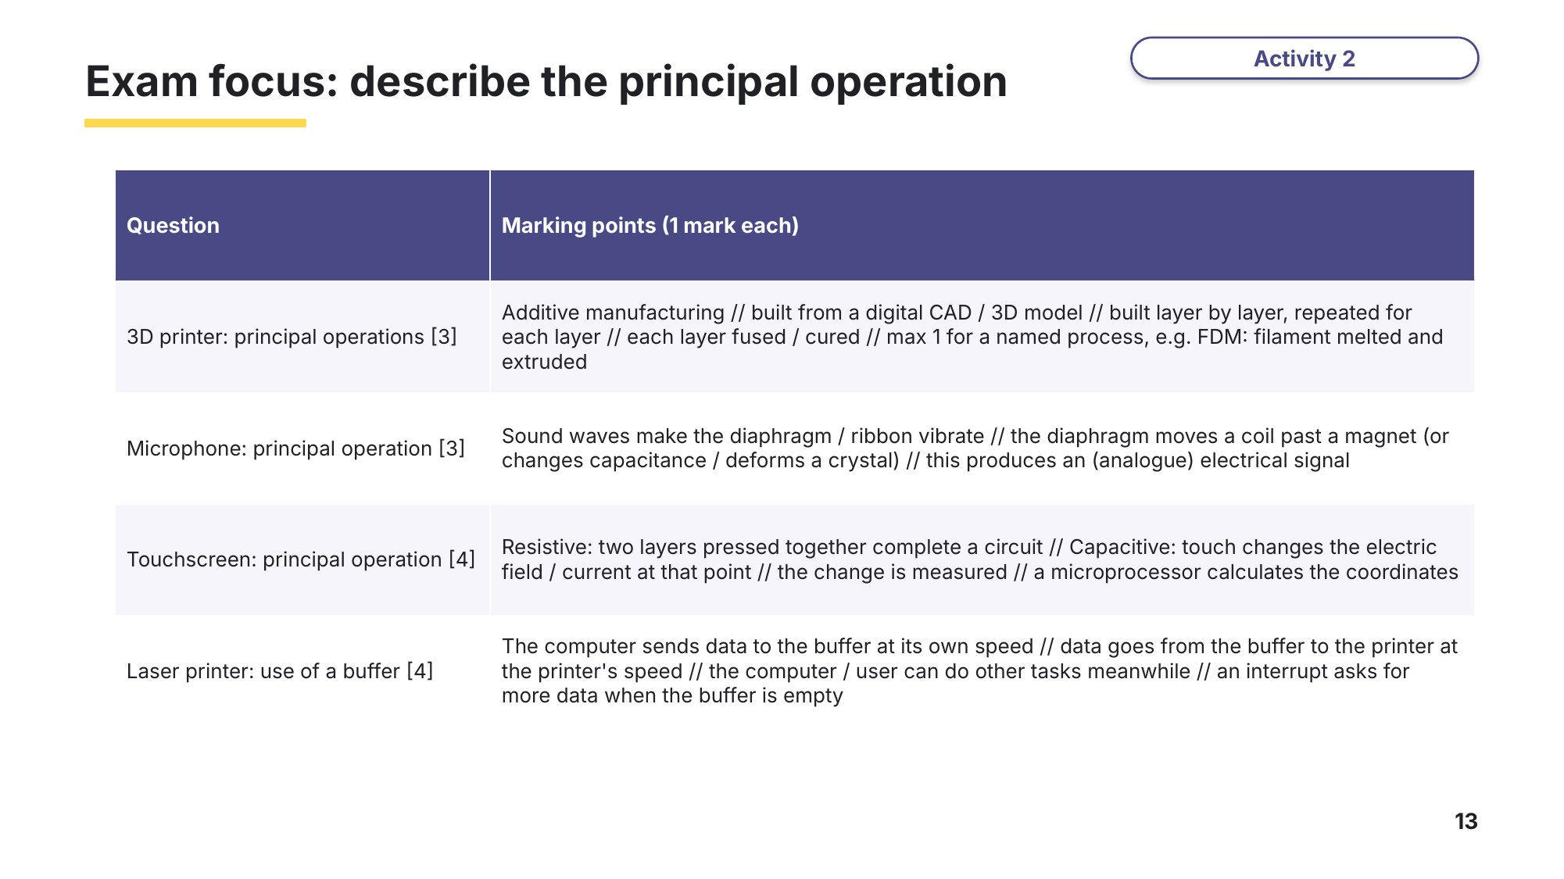
Slide 13 - Exam focus: describe the principal operation

Learn Monitoring and control systems
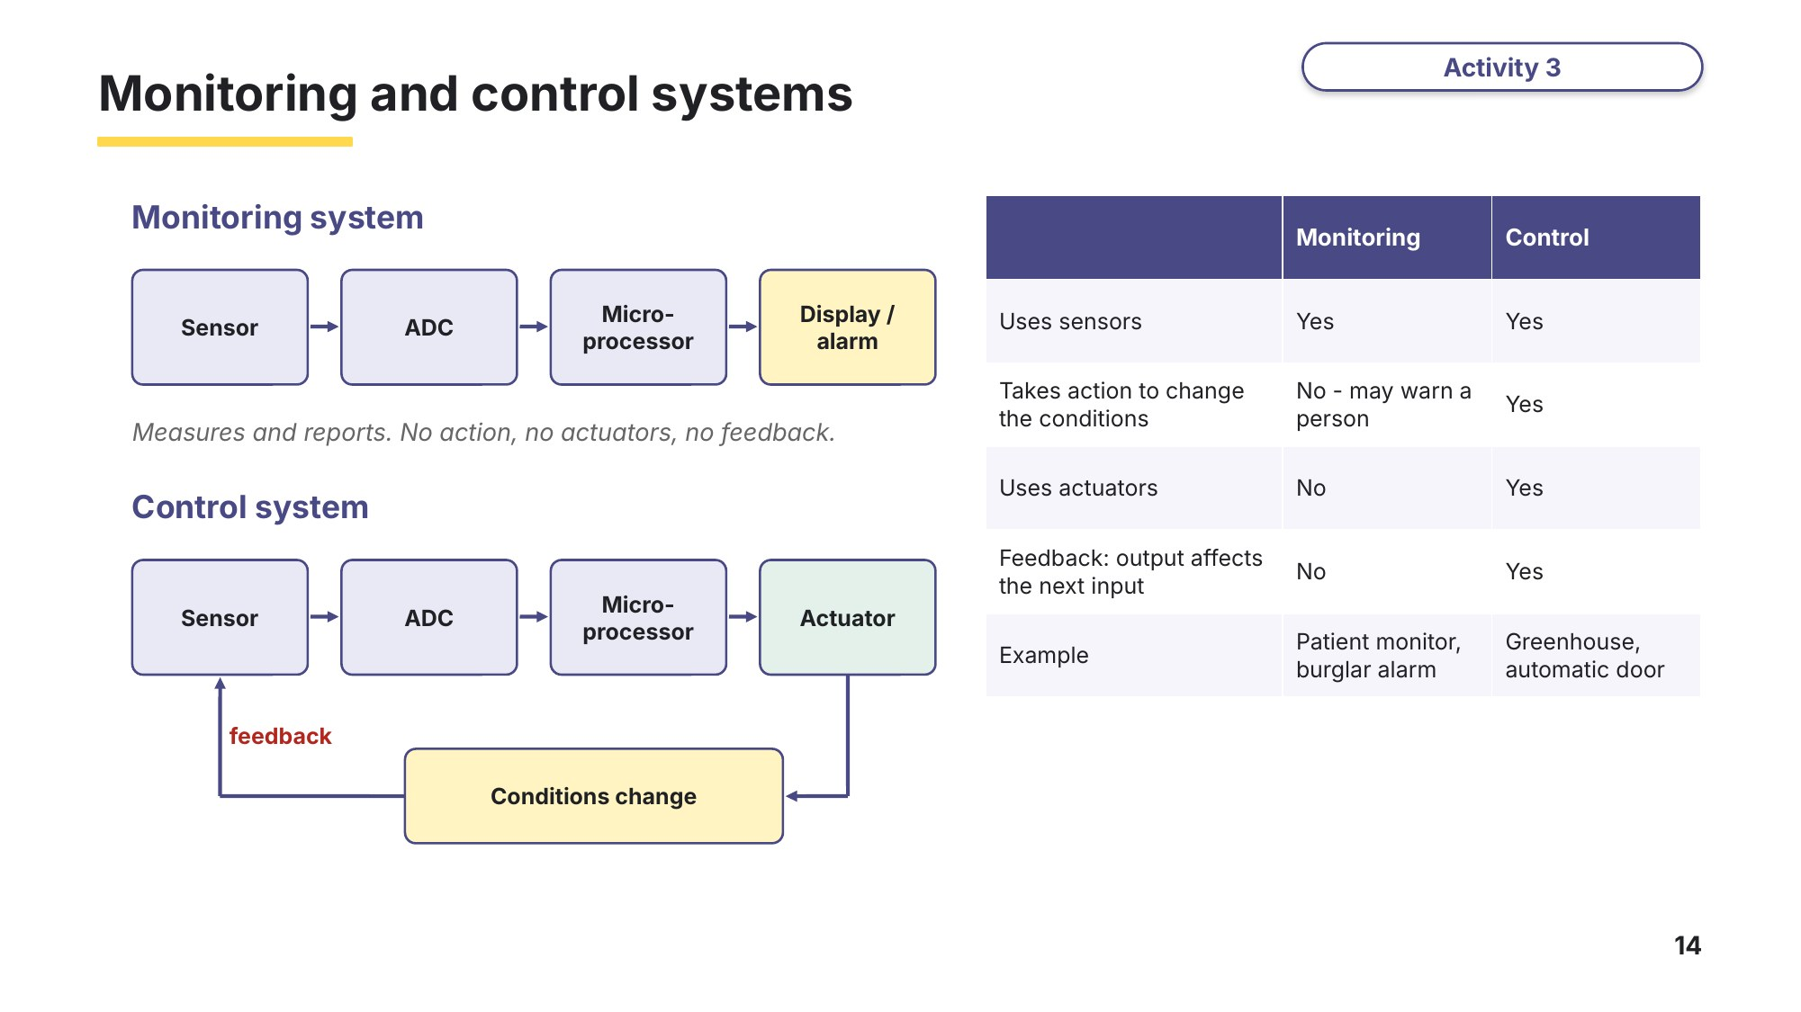
Slide 14 - Monitoring and control systems
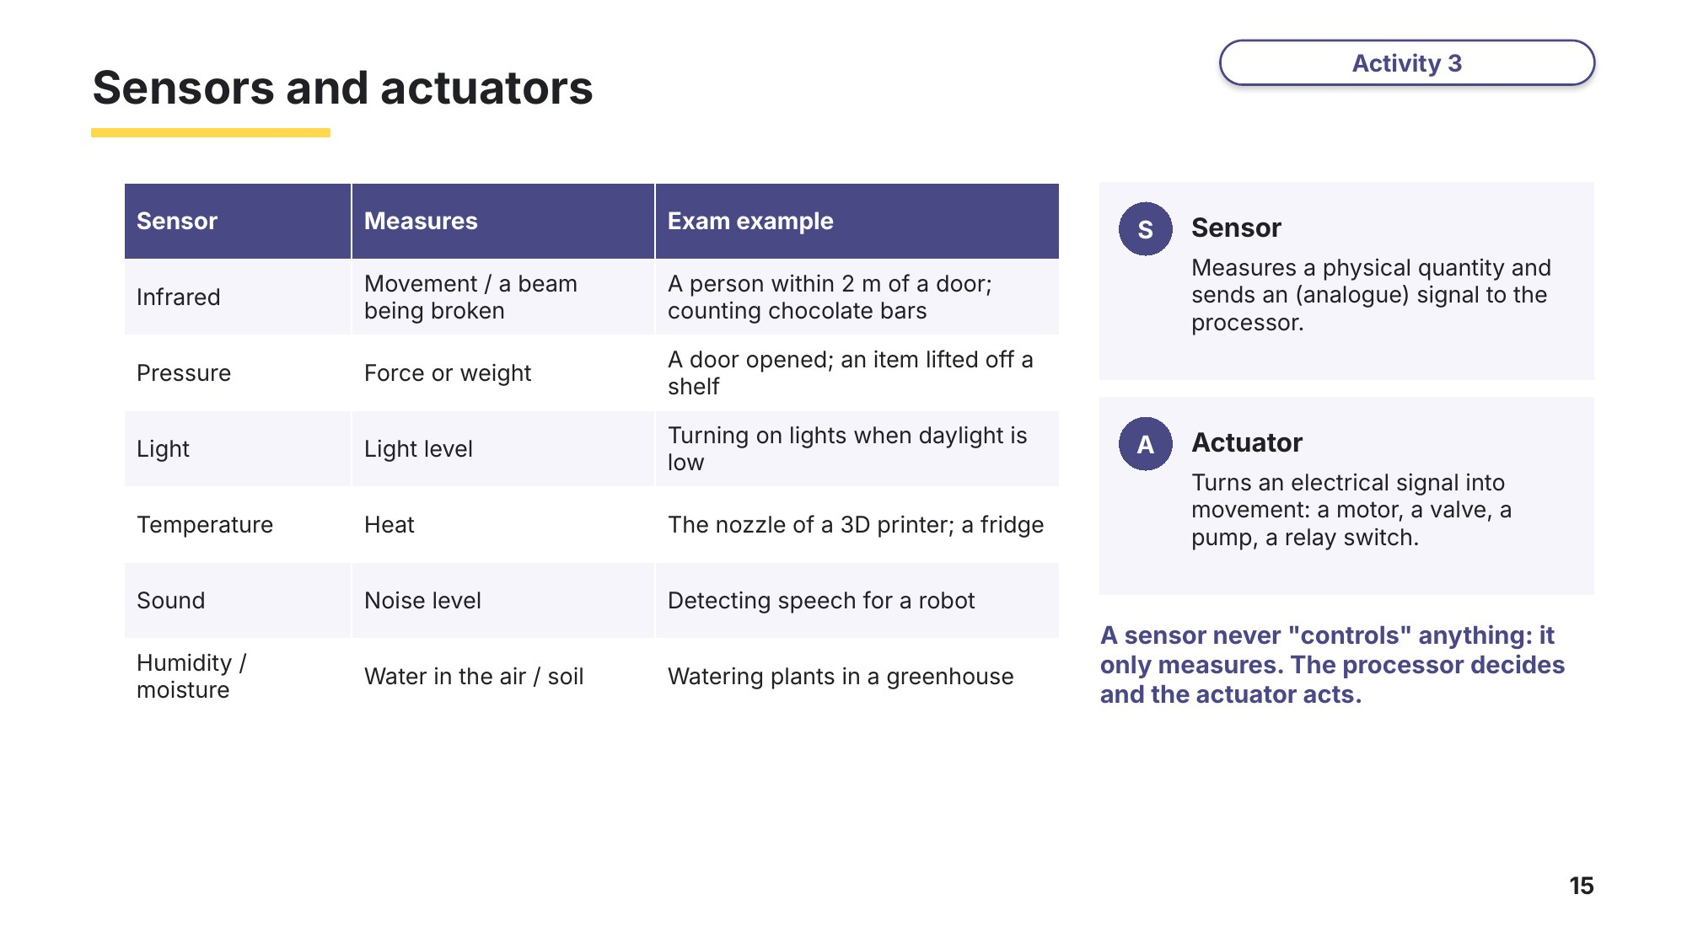
Slide 15 - Sensors and actuators
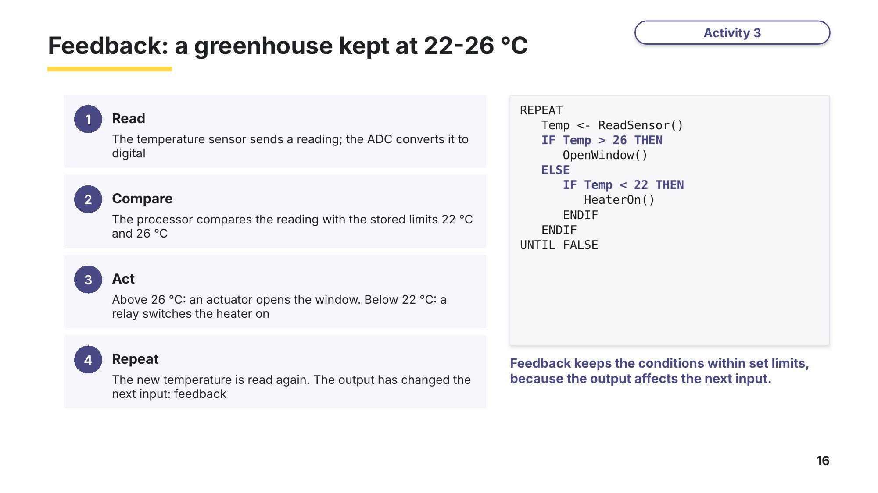
Slide 16 - Feedback: a greenhouse kept at 22-26 C
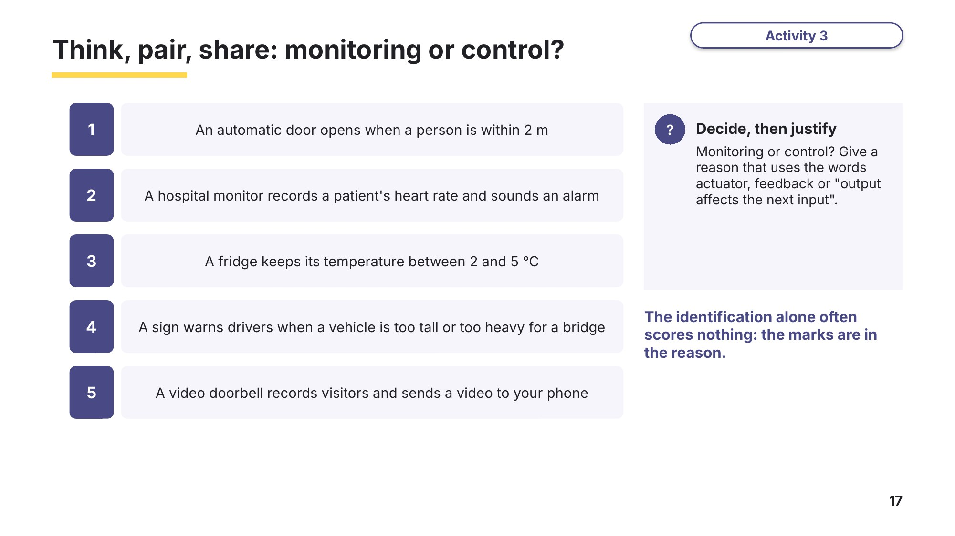
Slide 17 - Think, pair, share: monitoring or control?

Task 3 (continued)
(c) Identify the most appropriate type of sensor for each scenario. [5]
Scenario types based on 9618/11 Oct/Nov 2024 Q5(a).
Scenario | Sensor
The street lights turn on when it starts to get dark
A shop door opens when a person walks towards it
A library warns students when the room becomes too noisy
Plants in a greenhouse are watered when the soil becomes dry
An oven switches its heating element off when it is hot enough

(d) Tick one box in each row to show whether each system is a monitoring system or a control system. Give a reason for each choice. [4]
System | Monitoring | Control | Reason
Air conditioning keeps an office at 24 °C
A weather station records rainfall every hour
A camera photographs cars that are speeding
A car park barrier rises when a car is detected
Task 5 Exam questions: monitoring and control [16 marks]
(a) Describe the differences between a monitoring system and a control system. [3]
Based on 9618/11 Oct/Nov 2025 Q9.

(b) A supermarket has automatic doors that open when a sensor detects a person within 2 metres of the door. Identify whether this is a monitoring system or a control system. Justify your answer. [3]
Based on 9618/12 Oct/Nov 2025 Q11.
Type of system ..........................................

(c) Explain the importance of feedback in a control system. [2]
Based on 9618/11 Oct/Nov 2023 Q9(a).

A factory makes chocolate bars. The bars move along a conveyor belt. A sensor above the belt counts the bars. A second system weighs each bar and removes any bar that is the wrong weight from the belt.
(d)(i) Identify one appropriate type of sensor that can be used to count the bars. [1]

(d)(ii) Describe the role of an actuator in the second system. [2]
Based on 9618/12 Oct/Nov 2023 Q1.

(e) A restaurant uses a robot to take food from the kitchen to the tables. Identify two sensors the robot could use and give the purpose of each one. [2]
Based on 9618/13 May/June 2024 Q7(a).
Sensor 1 ............................... Purpose ......................................................................
Sensor 2 ............................... Purpose ......................................................................
(f) A house has a security system. Sensors detect when a door is opened or a person moves in a room, and an alarm sounds. Explain why this is a monitoring system and not a control system. [3]
Based on 9618/11 Oct/Nov 2024 Q5(c).

Learn Check your Task 5 answers
Only look at this slide once you have finished Task 5.
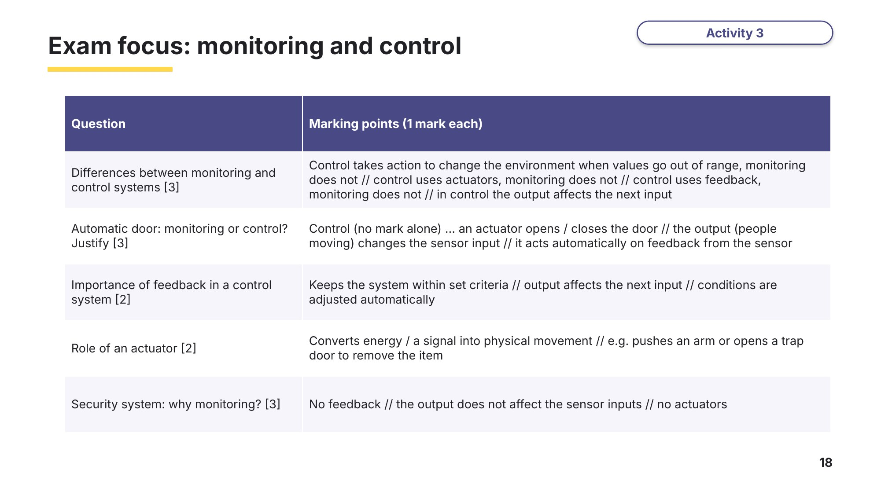
Slide 18 - Exam focus: monitoring and control

Task 6 Extension: design a greenhouse control system [10 marks]
A greenhouse must be kept between 22 °C and 26 °C, and the soil must not become too dry. A microprocessor controls the greenhouse.
(a) Identify two sensors the system needs and state what each one measures. [2]

(b) Identify two actuators the system could use and state what each one does. [2]

(c) Write an algorithm, as pseudocode or numbered steps, for the microprocessor. It must keep the temperature in range and water the soil when it is too dry. Show how feedback is used. [4]
(d) Explain why the system needs an analogue to digital converter (ADC). [2]

Learn Review
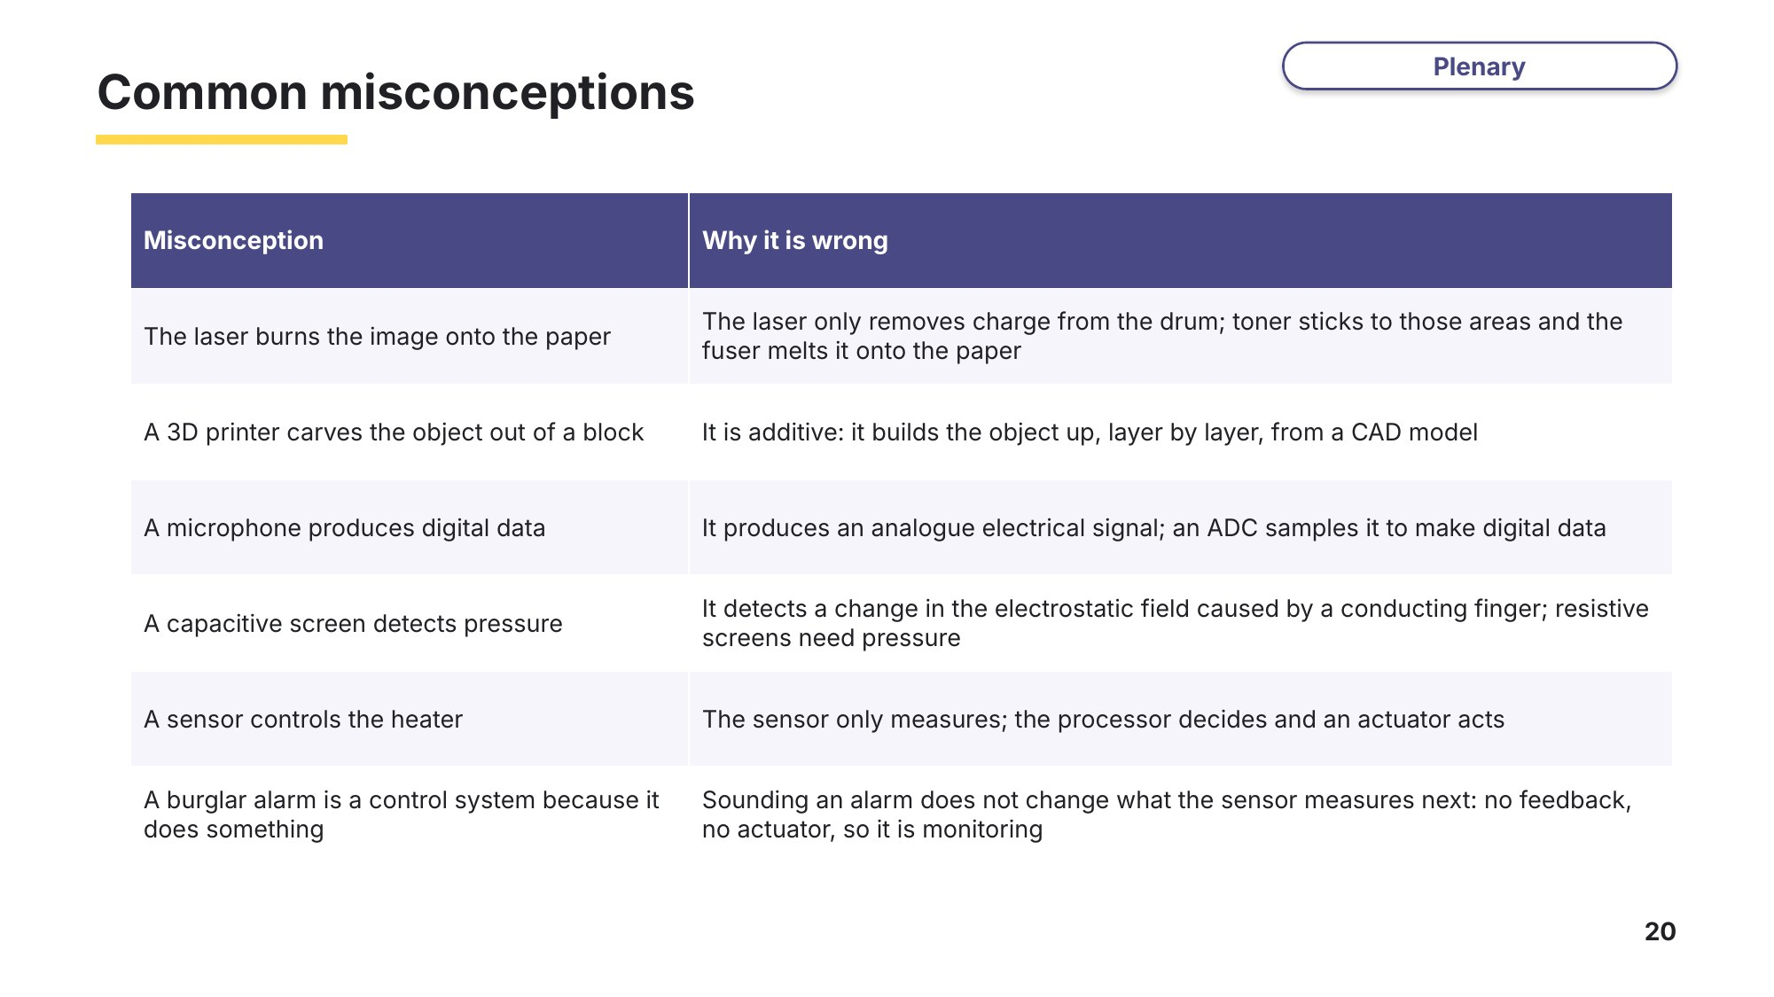
Slide 20 - Common misconceptions
Exit question
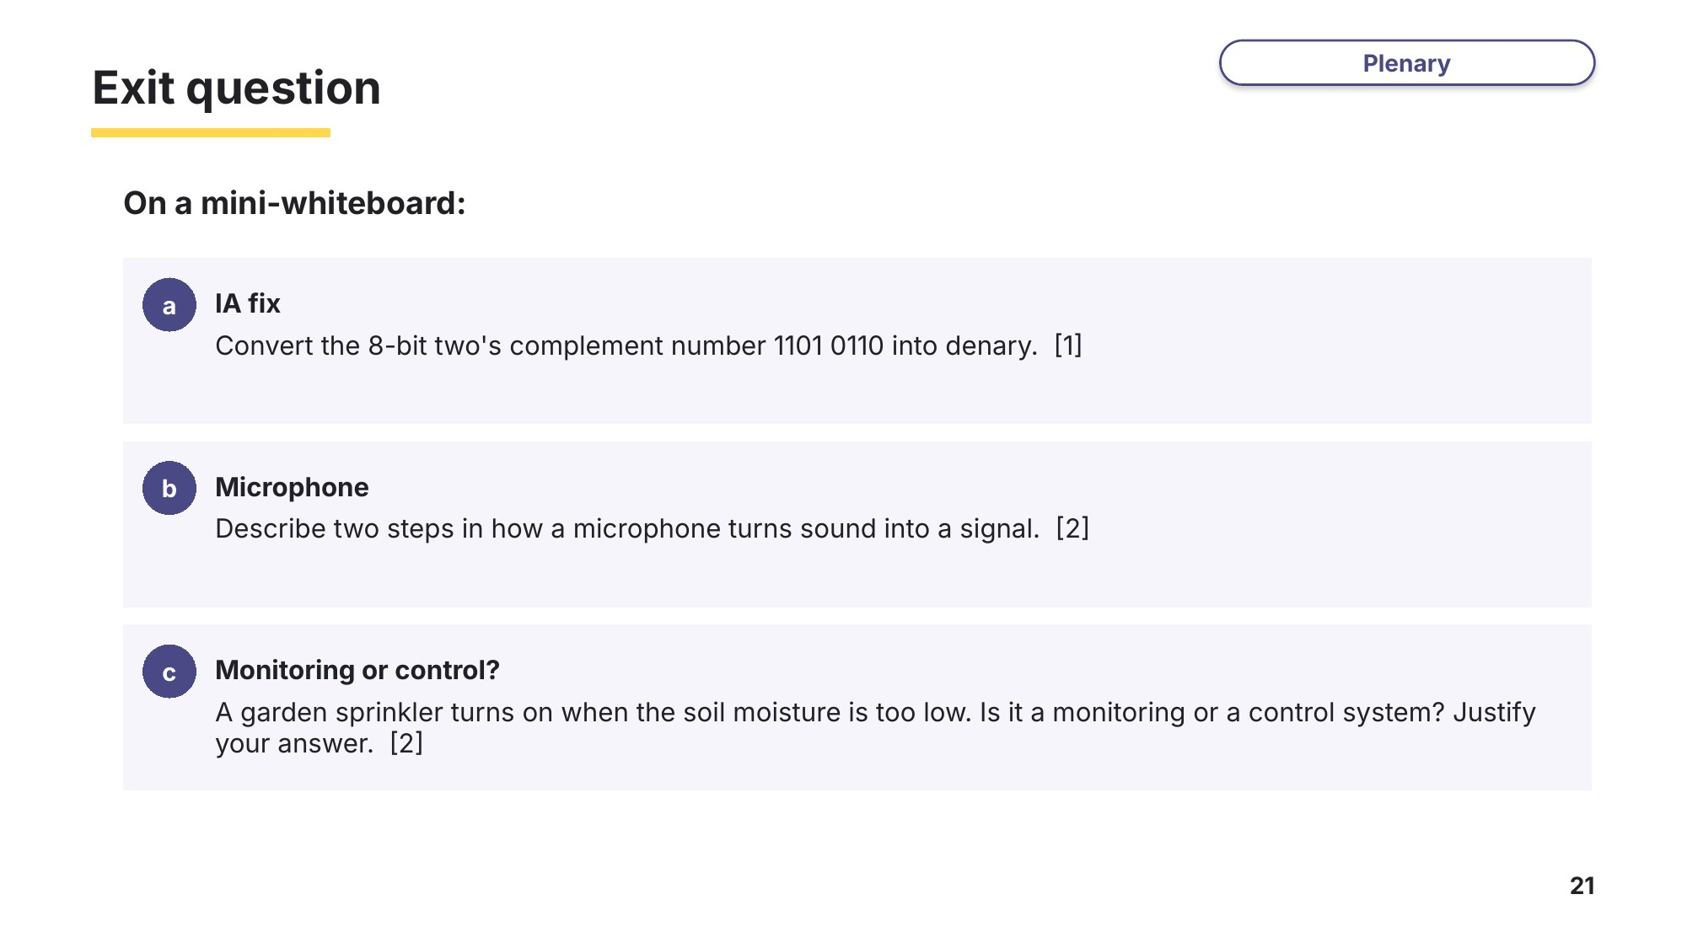
Slide 21 - Exit question

